Global synthesis of apple pollination research highlights general pollen limitation and positive contributions of wild bees compared to honeybees

Maxime Eeraerts*, Julia Osterman, Péter Batáry, Alexandra-Maria Klein, Matthias Albrecht, Georg K. S. Andersson, András Báldi, Olivia M. Bernauer, Leah Blechschmidt, Eleanor J. Blitzer, Paulo A. V. Borges, Jordi Bosch, Katherine L. W. Burns, Alistair J. Campbell, Sílvia Castro, James M. Cook, Robin Daelemans, Bryan N. Danforth, G. Arjen de Groot, Kinley Dorji, Rita Földesi, Hannah R. Gaines Day, Daniel García, Lucas A. Garibaldi, Michael P. D. Garratt, Andrew Gonzalez, Heather Grab, Claudio Gratton, Maren Kristine Halvorsen, Peter A. Hambäck, Bjørn Arild Hatteland, Olivier Honnay, Eva Hulsmans, Sandra Kaasen Vestheim, David Kleijn, Anikó Kovács-Hostyánszki, Martin J. Lechowicz, Nicolas Leclercq, Yunhui Liu, João Loureiro, Rachel E. Mallinger, Leon Marshall, Ivan Meeus, Marcos Miñarro, Diego N. Nabaes Jodar, Adara Pardo, Mia G. Park, Robert J. Paxton, Néstor Pérez-Méndez, Rafael A. Pincante De Carvalho, Paavo Pirttilehto, Matti Pisman, Simon G. Potts, Nigel E. Raine, James R. Reilly, Laura Roquer-Beni, Ulrika Samnegård, Dara A. Stanley, Louis Sutter, Kyle Teixeira-Martins, Simon M. Tierney, Ruan Veldtman, Nicolas J. Vereecken, Felix Wäckers, Timothy Weekers, Julianna K. Wilson, Panlong Wu, Kris Verheyen
*contact: maxime.eeraerts@gmail.com

Table of content
- Fig S1: Prisma flow diagram – p. 2
- Table S1: Overview of the studies identified through a systematic literature review, with study metadata, pollinator and pollination data – p. 3
- Table S2: Overview of the studies and their inclusion in the different objectives – p. 4
- Table S3: Methods of unpublished studies – p. 5
- Table S4: Average pollination efficiency values – p. 9
- Fig S2: Relative visitation of honeybees and the most common wild bee genera – p. 9
- Table S5: Number of effect sizes for each objective – p. 10
- Table S6: Model statistics of the categorical meta-analyses for each objective, considering early and final fruit set as separate pollination metrics – p. 11
- Table S7: Multi-level meta-regression test – p. 12
- Figures S3, S4: Funnel plots – p. 12
- Table S8: Model statistics of the categorical meta-analyses for each objective after trim-and-fill – p. 13
- Table S9: Multi-level meta-regression test after trim-and-fill – p. 14
- Figures S5, S6: Funnel plots after trim-and-fill – p. 14
- Supplementary acknowledgement – p. 15
- References – p. 16

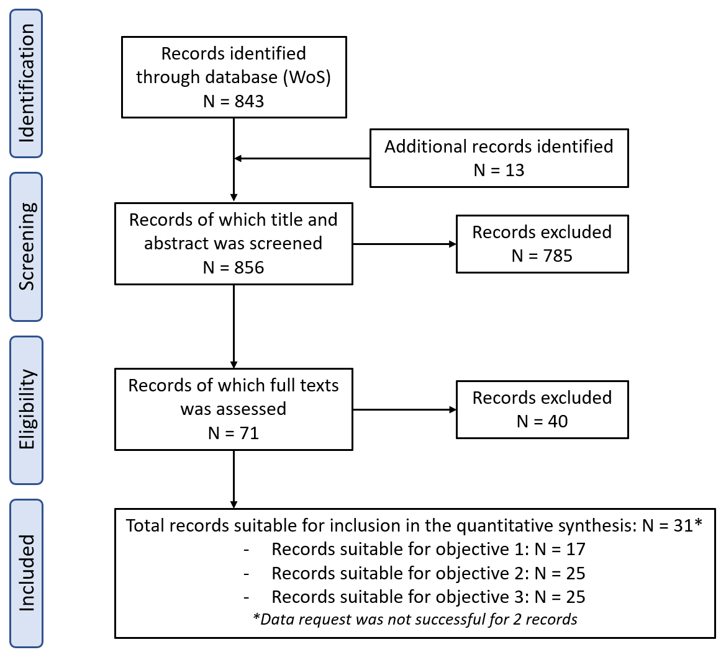
Fig S1: Prisma flow diagram showing the process of study selection.

Table S1: Overview of each study and its meta-data (SREC = study records, FS = fruit set, FW = fruit weight, SS = seed set, HB = honeybee, WB = wild bee, SR = bee species richness).
Study | Study ID | Country | Year(s) of sampling | Cultivar | # sites | # SREC | Initial/final FS | FS | FW | SS | HB | WB | SR
Garratt et al. 2014 | A01 | England | 2011 | Cox | 8 | 1 | Initial and final | X | X | X | X | X | X
Mallinger and Gratton 2015 | A02 | USA | 2012, 2013 | Mix | 17, 19 | 2 | Initial | X |  |  | X | X | X
Martins et al. 2015 | A03 | Canada | 2013 | McIntosh | 20 | 1 | Initial | X |  | X | X | X
de Groot et al. 2015 | A04 | Netherlands | 2013, 2014 | Elstar | 15, 15 | 2 | Final | X | X |  | X | X | X
Blitzer et al. 2016 | A05 | USA | 2013 | McIntosh, Golden | 8, 7 | 2 | NA |  | X | X | X | X | X
Földesi et al. 2016 | A06 | Hungary | 2012 | Relinda | 12 | 1 | Initial and final | X |  |  | X | X | X
Campbell et al. 2017 | A07 | England | 2013 | Mix | 8 | 1 | Initial and final | X |  |  | X | X
Nabaes and Garibaldi unpub | A08 | Argentina | 2019 | Gala, Red Delicious | 9, 19 | 2 | Final | X |  |  | X | X
Samnegard et al. 2019 | A09 | Sweden | 2015 | Aroma, Ingrid-Marie | 21, 5 | 2 | Initial | X | X | X | X | X | X
Martinez-Sastre et al. 2020 | A10 | Spain | 2015, 2016 | Regona | 25, 21 | 2 | Initial | X |  | X | X | X | X
Perez-Mendez et al. 2020 | A11 | Argentina | 2016 | Red Delicious | 8 | 1 | Final | X | X | X | X | X | X
Pardo et al. 2020 | A12 | Portugal | 2019 | Rennet | 6 | 1 | Initial | X | X | X | X | X | X
Reilly et al. 2020 | A13 | USA | 2013, 2014, 2015 | Gala | 5, 5, 5 | 3 | Final | X |  |  | X | X
Wu et al. 2021a | A14 | China | 2015 | Fuji | 12 | 1 | Initial | X | X | X | x | X | X
Wu et al. 2021b | A15 | China | 2015 | Fuji | 15 | 1 | Initial | X | X | X | X | X | X
Osterman et al. 2021 | A16 | Germany | 2017 | Pinova | 10 | 1 | Initial | X | X | X | X | X | X
Roquer-Beni et al. 2021 | A17 | Spain, Germany | 2015 | Gala, Golden, Braeburn | 9, 18, 27 | 3 | Initial and final | X | X | X | X | X | X
Burns and Stanley 2022 | A18 | Ireland | 2018 | Mix | 8 | 1 | Final | X | X | X | X | X | X
Pisman et al. 2022 | A19 | Belgium | 2019 | Jonagold | 12 | 1 | Final | X | X | X | X | X | X
Dorji et al. 2022 | A20 | Bhutan | 2020 | Mix | 9 | 1 | NA |  | X | X | X | X | X
Weekers et al. 2022 | A21 | Belgium, France | 2019 | Jonagold, Gala | 5, 9 | 2 | NA |  | X | X | X | X | X
Bernauer et al. 2022 | A22 | Australia | 2018 | Pink Lady | 5 | 1 | Initial | X |  | X | X | X | X
Hulsmans et al. 2023 | A23 | Belgium | 2019-2020 | Jonagold | 22, 23 | 2 | Initial | X | X | X | X | X | X
Veldtman unpub | A24 | South Africa | 2011 | Granny Smith | 11 | 1 | Initial and final | X | X | X | X
Hatteland et al. unpub | A25 | Norway | 2020 | Mix | 10 | 1 | NA |  | X | X | X | X | X
Raine and Blechschmidtunpub | A26 | Canada | 2018 | Gala | 6 | 1 | NA |  |  | X | X | X | X
Gaines-Day and Gratton unpub | A27 | USA | 2017 | Honeycrisp (mainly) | 13 | 1 | Final | X |  | X | X | X
Castro et al. unpub | A28 | Portugal | 2019 | Fuji, Rennet | 10, 10 | 2 | Final | X | X | X | X | X
Albrecht and Sutter unpub | A29 | Switzerland | 2018 | Gala, Mix | 12, 18 | 2 | Initial and final | X | X | X | X | X

Table S2: Overview of each study and its inclusion in each research objectives (HB = honeybees; WB = wild bees and SR = bee species richness). *Indicates studies that only surveyed pollinators by means of pan traps, which were excluded from objectives 2 and 3.
Study | Study ID | Objective 1 | Objective 2 | Objective 3
 |  |  |  | HB | WB | SR
Garratt et al. 2014 | A01 |  | X | X | X | X
Mallinger and Gratton 2015 | A02 | X | * | * | * | *
Martins et al. 2015 | A03 | X | X | X | X
De Groot et al. 2015 | A04 |  | X | X | X | X
Blitzer et al. 2016 | A05 | X | X | X | X | X
Földesi et al. 2016 | A06 |  | X | X | X | X
Campbell et al. 2017 | A07 |  | X | X | X
Nabaes and Garibaldi unpublished | A08 | X | X | X | X
Samnegard et al. 2019 | A09 | X | X | X | X | X
Martinez- Sastre et al. 2020 | A10 | X | X | X | X | X
Perez-Mendez et al. 2020 | A11 |  | X | X | X | X
Pardo et al. 2020 | A12 | X | X | X | X | X
Reilly et al. 2020 | A13 |  | X | X | X
Wu et al. 2021a | A14 |  | * | * | * | *
Wu et al. 2021b | A15 | X | * | * | * | *
Osterman et al. 2021 | A16 | X | X | X | X | X
Roquer-Beni et al. 2021 | A17 | X | X | X | X | X
Burns and Stanley 2022 | A18 | X | X | X | X | X
Pisman et al. 2022 | A19 | X | X | X | X | X
Dorji et al. 2022 | A20 |  | X | X | X | X
Weekers et al. 2022 | A21 |  | X | X | X | X
Bernauer et al. 2022 | A22 |  | X | X | X | X
Hulsmans et al. 2023 | A23 | X | * | * | * | *
Veldtman unpublished | A24 | X | X | X
Hatteland et al. unpublished | A25 | X | X | X | X | X
Raine and Blechschmidt unpublished | A26 |  | X | X | X | X
Gaines-Day and Gratton unpublished | A27 |  | X | X | X
Castro et al el. unpublished | A28 |  | X | X | X
Albrecht and Sutter unpublished | A29 | X | X | X | X

Table S3: Description of the materials and methods of the unpublished studies.
Study | Material and methods
Nabaes et al. | The study was performed in a large agricultural and heavily urbanized valley called the Alto Valle of Río Negro and Neuquén, with sites distributed between the localities of San Patricio del Chañar and Guerrico. We surveyed 30 one-hectare orchard plots, separated by at least 900 m, of which 15 were in organic certified orchards and the other 15 were conventional. The cultivars sampled were Cripps Pink, Red Delicious and Gala. Orchards were sampled in the 2019-2020 growing season, with the blooming period between September and October 2019, and the harvest period between February and April 2020. The transect walks for the observation of apple flower insect visitors were repeated six times per orchard, in the same day. Three of these walks were performed in a transect at the edge of each apple plot, and three were performed in a transect at the center of each plot. Each transect had an area of 450 m², and each walk lasted 5 minutes. The number of observed flowers in each transect was also registered to standardize the visitor counts. The taxa sampled were bumblebees, honey bees, other wild bees, non bee Hymenoptera, Lepidoptera, Coleoptera, Syrphidae, and other Diptera, and they were identified to morphospecies or family, unless genus or species were known. The only pollination treatment applied was the exclusion of pollinators from flowers with bags around branches covering ~5 inflorescences (~25 flowers), to be compared with similar open branches (untreated inflorescences). We set ten bags per orchard and marked and sampled 20 open branches (half in the same tree as a bag, and half in a different tree). Half of the open and excluded branches were set at the orchard plot edge and half at the center. The number of opened flowers in the marked and bagged branches were counted once during bloom, which is enough given the high synchrony of apple trees. We determined the final fruit set (during harvest), and measured weight (gram) and size (diameter, cm).
Veldtman | We sampled 12 ‘Granny Smith’ apple orchards in the 2008/2009 fruit production period located in the Ceres and Witzenberg valleys and the Elgin, Grabouw and Villiersdorp area in South-Africa. Each orchard was a homogenous unit with regard to cultivars planted for cross pollination, type of rootstock and farming practices, but these varied between orchards. However, all orchards were conventionally managed and subjected to management practices that promote flowering followed by fruit thinning.  In September/October 2008 honey bee abundance in each orchard was determined by the same observer counting all honey bees seen within 1 minute on one side of a tree. This was done for six adjacent trees in five rows thus sampling a total of thirty trees for 30 minutes per orchard. Surveys were all conducted when orchards were at 50% of full bloom on clear, sunny days, between 09:00 and 12:00, with a temperature of >18°C, and wind speed of <15 km/hr.  To determine initial and final fruit set in each of the 12 study orchards, branches on 25 trees were selected and marked (five adjacent trees per row in five rows randomly selected throughout the orchard). In October/November 2008 the number of fruitlets formed per branch was counted 30 days after flowering ended (initial set). In March/April 2009, ≤5 days before an orchard was harvested, fruit were counted (final fruit set) and a maximum of 30 fruit per orchard were collected (with a maximum of five fruit per marked branch) to determine seed-set in the laboratory.
Hatteland et al. | The study took place in ten apple orchards in Western Norway. There were four sites in the region of Sogn and six in Hardanger. Each site consisted of one orchard with one or two cultivars, and the ten different sites/orchards summed up to a total of four “Aroma” orchards, two “Summerred”, two “Gravenstein” and two orchards with a mixture of “Aroma” and “Discovery”. The minimum distance between two orchards were 2 km. The minimum area of each orchard was 3000 m², to ensure that the orchards were comparable.  Bees were collected in May and June 2020, during the flowering season of the apple orchards using two different trapping techniques. Active trapping was performed by doing netting walks capturing bees using nets. In addition, we also deployed pan traps on the days that netting walks were performed. We only collected bees on days with no precipitation and a higher temperature than 10°C. Sampling was done between one and three consecutive days at each site. Each netting walk lasted 90 minutes and covered the entire orchard. During these walks, only bees visiting apple flowers were captured. These walks were done in the morning (often starting around 9 AM) and in the afternoon (often starting around 14 PM).  For each field, nine pan traps were put out before the first netting walk of the day and emptied after the last walk, thus sampling for 5-8 hours. However, in four of the total 24 sets of traps, traps were left sampling through the night to the next morning. The traps consisted of 500 ml plastic bowls painted using fluorescent colours: yellow, blue, and white, using blue Liquitex and yellow and white Rocol paints. Three sets of trap triplets, one of each colour in all triplets, were placed in different locations of the field. One group of traps was placed in the middle of the field, the other two were placed in opposite corners of the field. Within each triplet, the traps were placed approximately 2m away from each other along the rows of apple trees. The bees and other captured insects were dried and placed in a freezer.  All the captured bees were identified to species. The three species Bombus lucorum, cryptarum and magnus were separated using morphological traits, but should ideally be distinguished using DNA barcoding.  Apples for seed set analyses were collected at harvest time in September. A total of 100 apples were collected per orchard, of which 10 apples were sampled per 10 randomly chosen trees. Apples were collected from several branches per trees. In the two orchards consisting of two cultivars only “Aroma” apples were picked. Seeds were counted from alle harvested apples and classified as fully developed, partly developed or not developed.
Blechschmidt and Raine | This study examined flower-visitor diversity and fruit quality on apple farms in Ontario, Canada. Fourteen farms across the southern Ontario apple-growing region were chosen for data collection, with farms spaced at least 4000m apart based on typical foraging ranges of wild bees. All farm used conventional management practices, including the application of various agrochemicals (including fungicides and herbicides) and the antibiotic streptomycin during bloom, and twelve of the farms stocked colonies of managed honeybees for pollination. Sampling took place during apple bloom in May 2018 across selected gala cultivar blocks, chosen for their economic significance. Three rows of gala apples were sampled at each site, with each row featuring sampling points at 5, 50, and 100m distances from the row edge to capture flower visiting insect diversity across the orchard. Climatic conditions such as temperature, humidity, wind speed, and cloud cover were recorded during sampling times when bees are typically active. For pollinator observations, 1m x 1m sections of each row were established, and bees observed within these areas were actively captured and recorded, focusing on species visiting apple blossoms rather than using passive trapping methods, which can misrepresent active flower visitor populations. Captured specimens were stored at -20°C for later identification. Most specimens were identified to the genus level, with species-level identification achieved for certain genera through DNA barcoding. The identified bees included several genera commonly found in agricultural settings, and all specimens were preserved at the Raine Pollinator Lab at the University of Guelph. Apple pollination metrics, including fruit weight and seed count, were measured for tagged apples at seven farms in the post-harvest period. These indicators of pollination quality were selected based on industry standards for desirable traits.
Gaines-Day and Gratton | This study was performed in April and May 2017 at thirteen commercial apple orchards across southern Wisconsin (USA) ranging from 1.6 to 20.2 ha. All observations were done on dwarf Honeycrisp except one orchard where we sampled dwarf Royal Cortland and another where we sampled both Honeycrisp and Empire. A central lane within the focal orchard block was designated as our sampling transect. Ten trees in the center of this lane (5 trees on either side of the lane) were flagged for measuring bee visitation and fruit set. Trees were ~5 meters apart from each other. To measure the visitation rate (visits/flower/minute) by insects to apple blossoms, we did timed, 5-minute focal observations on 5 trees per orchard within our focal orchard lane. Insect visitors were categorized into the following morpho-groups: honey bee, bumble bee, large dark (Andrena), dark striped (small, medium, large), small/tiny dark (Lasioglossum), metallic green bee, mason bee (Osmia), Ceratina spp., fly, or wasp. Observations were done on warm days (14º – 24º C) with little wind (< 2.5 m/s) when the observers’ shadow was visible (sky was sunny to bright overcast). To meet these criteria, all observations were done between 11am and 5pm. Observations were done at each study orchard once per season between April 25 – May 13, 2017. Weather in this study system is highly variable in the spring resulting in few days with weather appropriate for making bee observations. Furthermore, apple bloom is very short, preventing more than one visit per orchard. To determine fruit set, we counted buds (pre-bloom) and fruitlets (post-bloom) on 10 flagged trees in each orchard. Counts were done in the outer 1 m of a single, lateral branch per tree at 1–2 m high. Fruitlets were counted during the early fruit set period before fruit drop. Total seeds from 5-10 fruitlets per tree, harvested at the same time as fruit set assessments, were counted in the lab.
Castro et al. | Pollinator communities were studied in the Oeste Region, Portugal, between April 16 and May 5, 2019. A total of 20 apple orchards with integrated pest management were selected, including 10 ‘Fuji’ and 10 ‘Reineta’ orchards. Plant-pollinator interactions were recorded through direct observations during the apple orchard flowering peak in several randomly selected branches. The observer was positioned at approximately 1.5 m from the tree, being able to monitor all floral visitors without disturbing their foraging activity. Floral visits were recorded during 1 min census periods at different hours, from 09:00 to 18:00h (GMT+1), for three days. During each census, pollinator insects were identified in morphospecies and several specimens per morphospecies were collected to confirm their identification in the laboratory. All pollinator insects were identified at the genus, subgenus, species and morphospecies level. Fruit was quantified in all studied orchards. For this, seven trees were selected, and for each tree six inflorescences with five flowers each were tagged during flowering. When fruits were ripe, the fruit set was recorded, and fruits harvested. In the laboratory, fruits were weighted individually. Then, fruits were cut transversally and the number of morphologically viable seeds counted to quantify seed set.
Albrecht and Sutter | The study was conducted in 2018 in the cantons of Aargau and Zürich (Swiss plateau, 12 sites) and in the canton of Wallis (13 sites). The region on the Swiss plateau is characterized by a mixed production system with agricultural landscapes consisting of a small-scaled mosaic of arable and permanent crops, agricultural grasslands and semi-natural habitats such as semi-natural grasslands, forest remnants hedgerows and sown flower strips. The studied region in the canton of Wallis (Rhone valley) is dominated by permanent crops (top fruit and berry production, viticulture), arable crops, agricultural grasslands and semi-natural habitats (e.g., semi-natural grasslands, shrublands, forests, hedgerows). Study sites were at least of two kilometers apart from each other. Bees and hoverflies were sampled using standardized transects walks: transects of 75 m length were walked for 10 min at a constant pace while recording all individual bees visiting crop ﬂowers (i.e., contacting ﬂower reproductive organs). In each orchard, four transects were walked during each of up to five sampling rounds during peak flowering of apple (from mid-April until end of April). Transects were walked along two tree lines in the central zone and additionally along two tree lines of a randomly selected edge zone of each orchard. Flower-visiting bees (Apoidea) were identiﬁed in the ﬁeld to species level, or, if this was not possible, collected and identiﬁed to species level in the laboratory by experts. Time was stopped for the duration of insect handling of bees (catching and transfer to killing jar). In each orchard, a total of eight trees (up to two different varieties per orchard) were randomly selected (four in the central zone, four in the edge zone) and randomly assigned to pollination treatments. Of each tree, flowers of two branches, one in the lower part (ca. 50-150 cm) and one in the upper part (ca. 150-250 cm) were chosen. For the supplemental hand pollination treatment, pollen collected from different (at least four) donor varieties including wild types (to assure ensure high genetic variety and thus optimal fertilization rate of the hand pollinated flowers) was applied on stigmas of freshly opened flowers using a brush. On the same day, the same number and freshly opened flowers were marked within the same height class (see above) of the same tree for the open pollination treatment. The number of flowers used for each pollination treatment was recorded and flowers marked. Early fruit set was determined as the percentage of flowers developing into a fruit before thinning by producers and/or fruit abortion, late fruit set was determined shortly before harvest.

Table S4: Average pollination efficiency values relative to that of the honeybee (Apis) extracted from studies that measure the pollination efficiency of different wild bee genera, measured as single visit (SV) fruit set and single visit pollen deposition. The average pollination efficiency relative to the honeybee is calculated by taking the average of the values of the different studies. In order to calculate the relative pollination contribution, the average SV efficiency was calculated for honeybees (Apis), bumblebees (Bombus) and other wild bees (Andrena, Lasioglossum and Osmia).
 |  | SV pollination efficiency relative to the honeybee
Study | Pollination metric | Apis | Andrena |  | Bombus |  | Lasioglossum |  | Osmia
Kuhn and Ambrose 1984 | SV fruit set | 1 |  |  |  |  |  |  | 1.58
Vicens and Bosch 2000 | SV fruit set | 1 |  |  |  |  |  |  | 5.71
Thompson and Goodell 2001 | SV pollen deposition | 1 |  |  | 1.73
Park et al. 2016 | SV pollen deposition | 1 | 2.5 |  | 1.5
Garratt et al. 2016 | SV fruit set | 1 |  |  | 1.73 |  |  |  | 1.98
Roquer-Beni et al. 2022 | SV pollen deposition | 1 | 1.69 |  | 1.29 |  |  |  | 1.65
Bernauer et al. 2022 | SV pollen deposition | 1 |  |  |  |  | 1.30
Average SV pollination efficiency per bee group
Apis | 1
Bombus | 1.56
Other wild bees | 2.28

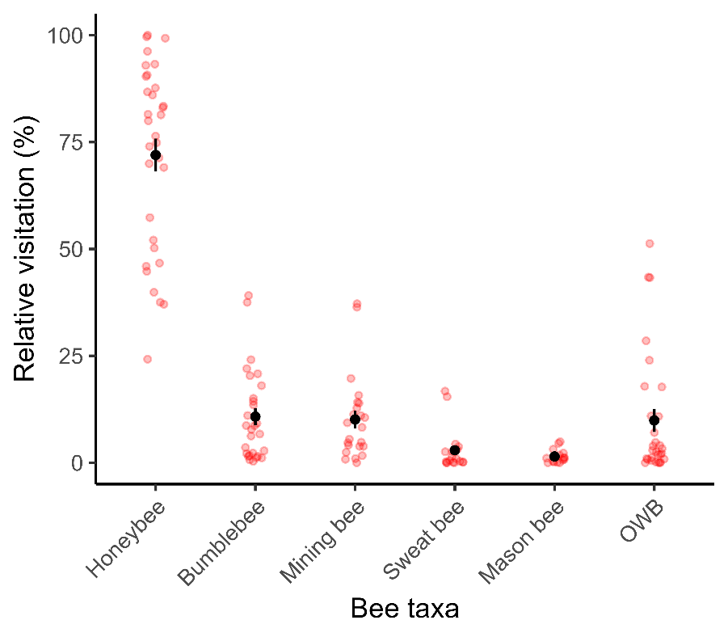
Figure S2: The relative visitation of the honeybee and the most common bee genera in apple studies across the world (Bumblebee = Bombus spp., mining bee = Andrena spp., sweat bee = Lasioglossum spp., mason bee = Osmia spp., and OWB = other wild bees not belonging to the aforementioned wild bee genera). The red dots indicate data points, the black dots and whiskers indicate the mean and standard error of the mean.

Effect sizes overview
Table S5: Number of effect sizes included in the meta-analyses per objective and per pollination metric (corresponding number of study records in parenthesis). In red the number of effect sizes used in the analyses for objective 3, after excluding the study records that showed high collinearity in the linear model for calculating the effect sizes.
Objective | Fruit set | Fruit weight | Seed set | Total
Objective 1 – Pollen limitation | 28 (22) | 15 (15) | 16 (16) | 58 (26)
Objective 3 – Honeybees | 38 (30) | 27 (26) | 32 (28) | 98 (38)
 | 34 (26) | 23 (22) | 25 (22) | 82 (31)
Objective 3 – Wild bees | 37 (29) | 26 (25) | 31 (27) | 94 (36)
 | 32 (25) | 22 (21) | 24 (21) | 78 (30)
Objective 3 – Bee species richness | 22 (17) | 20 (19) | 25 (21) | 67 (24)

Summary statistics of meta-analyses models (Obj. 2 and 3)
Table S6: Results of the set of random-effects categorical meta-analyses using pollination metric as a moderator variable for each objective (PL = pollen limitation, HB = honeybee contribution, WB = wild bee contribution, SR = bee species richness contribution). Early and final fruit set (FS) were considered as separate pollination metrics. Model statistics reported are the model estimate, standard error (SE), p-value, lower 95% confidence interval and upper 95% confidence interval). Residual heterogeneity of the different meta-analyses models is also given (Q_{res} and p-value (p_{res})), as well as the moderator heterogeneity of each model (Q_{mod} and p-value (p_{mod})).
Objective | Moderator | Estimate | SE | p | LCI | UCI | Q_{res} | p_{res} | Q_{mod} | p_{mod}
Objective 1: PL | Early FS | 2.38 | 0.20 | <0.001 | 1.98 | 2.77 | 249.30 | <0.001 | 217.78 | <0.001
 | Final FS | 1.11 | 0.20 | <0.001 | 0.71 | 1.50
 | Fruit weight | -0.16 | 0.19 | 0.40 | -0.52 | 0.21
 | Seed set | 0.85 | 0.19 | <0.001 | 0.48 | 1.21
Objective 3: HB | Early FS | 0.03 | 0.08 | 0.70 | -0.13 | 0.17 | 335.68 | <0.001 | 14.24 | <0.01
 | Final FS | -0.11 | 0.08 | 0.15 | -0.27 | 0.04
 | Fruit weight | -0.15 | 0.07 | 0.04 | -0.29 | -0.01
 | Seed set | 0.09 | 0.07 | 0.22 | -0.05 | 0.23
Objective 3: WB | Early FS | 0.08 | 0.06 | 0.19 | -0.04 | 0.21 | 165.37 | <0.001 | 16.39 | <0.01
 | Final FS | -0.07 | 0.06 | 0.27 | -0.19 | 0.05
 | Fruit weight | 0.12 | 0.06 | 0.04 | 0.01 | 0.23
 | Seed set | 0.17 | 0.05 | 0.01 | 0.06 | 0.27
Objective 3: SR | Early FS | -0.01 | 0.10 | 0.95 | -0.21 | 0.20 | 239.63 | <0.001 | 9.58 | 0.048
 | Final FS | -0.07 | 0.11 | 0.55 | -0.29 | 0.15
 | Fruit weight | 0.14 | 0.09 | 0.14 | -0.05 | 0.32
 | Seed set | 0.17 | 0.09 | 0.05 | 0.01 | 0.34

Publication bias test (Obj. 2 and 3)
Table S7: Results of the publication bias test with multi-level regression test (model statistics reported are the model estimate, standard error (SE) and p-value).
Objective | estimate | SE | p
Objective 1: Pollen limitation | -2.15 | 2.29 | 0.35
Objective 3: Honeybee visitation | 0.72 | 1.01 | 0.47
Objective 3: Wild bee visitation | 0.90 | 0.69 | 0.19
Objective 3: Bee species richness | 1.03 | 1.02 | 0.31

Fig. S3: Funnel plots showing the relationship between effect size and standard error for pollen limitation.
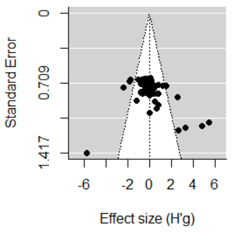

Fig. S4: Funnel plots showing the relationship between effect size and standard error for the pollination contribution of honeybees (A), wild bees (B) and bee species richness (C).
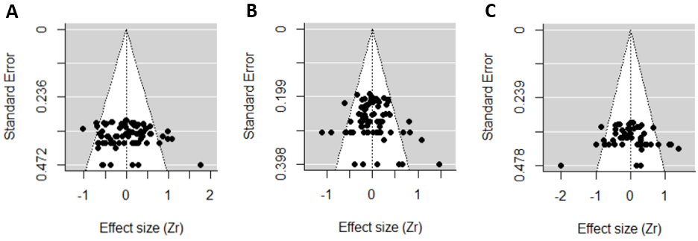

Summary statistics and publication bias of meta-analyses after trim-and-fill (Obj. 2 and 3)
Table S8: Results of the set of random-effects categorical meta-analyses using pollination metric as a moderator variable for each objective (PL = pollen limitation, HB = honeybee contribution, WB = wild bee contribution, SR = bee species richness contribution). Model statistics reported are the model estimate, standard error (SE), p-value, lower 95% confidence interval and upper 95% confidence interval). Residual heterogeneity of the different meta-analyses models is also given (Q_{res} and p-value (p_{res})), as well as the moderator heterogeneity of each model (Q_{mod} and p-value (p_{mod})).
Objective | Moderator | Estimate | SE | p | LCI | UCI | Q_{res} | p_{res} | Q_{mod} | p_{mod}
Objective 1: PL | Fruit set | 1.33 | 0.10 | <0.001 | 1.14 | 1.52 | 129.85 | <0.001 | 215.82 | <0.001
 | Fruit weight | -0.12 | 0.11 | 0.27 | -0.34 | 0.10
 | Seed set | 0.55 | 0.11 | <.001 | 0.34 | 0.77
Objective 3: HB | Fruit set | -0.08 | 0.07 | 0.27 | -0.21 | 0.06 | 315.44 | <0.001 | 12.22 | <0.01
 | Fruit weight | -0.15 | 0.07 | 0.04 | -0.30 | -0.01
 | Seed set | 0.07 | 0.07 | 0.33 | -0.07 | 0.21
Objective 3: WB | Fruit set | -0.01 | 0.05 | 0.97 | -0.09 | 0.09 | 124.92 | <0.001 | 11.62 | <0.01
 | Fruit weight | 0.13 | 0.06 | 0.021 | 0.02 | 0.24
 | Seed set | 0.14 | 0.05 | <0.01 | 0.04 | 0.24
Objective 3: SR | Fruit set | 0.03 | 0.07 | 0.66 | -0.11 | 0.17 | 229.47 | <0.001 | 9.75 | 0.021
 | Fruit weight | 0.08 | 0.08 | 0.29 | -0.07 | 0.23
 | Seed set | 0.19 | 0.07 | <0.01 | 0.06 | 0.33

Publication bias test after trim-and-fill (Obj. 2 and 3)
Table S9: Results of the publication bias test with multi-level regression test (model statistics reported are the model estimate, standard error (SE) and p-value).
Objective | Estimate | SE | p
Objective 1: Pollen limitation | -0.50 | 1.28 | 0.70
Objective 3: Honeybee visitation | -1.12 | 0.80 | 0.16
Objective 3: Wild bee visitation | 0.25 | 0.66 | 0.71
Objective 3: Bee species richness | 1.42 | 0.89 | 0.12

Fig. S5: Funnel plots showing the relationship between effect size and standard error for pollen limitation.
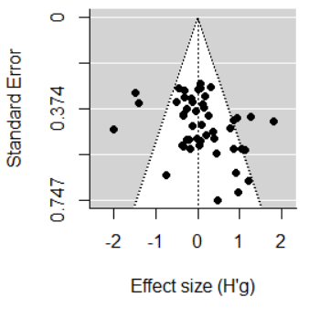

Fig. S6: Funnel plots showing the relationship between effect size and standard error for the pollination contribution of honeybees (A), wild bees (B) and bee species richness (C).
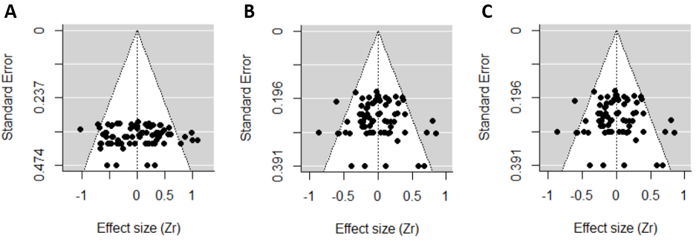

Supplementary acknowledgment

We are thankfull to Madelé Mouton for their support with collecting the data. AMK was funded through the 2013–2014 BiodivERsA/FACCE-JPI joint call (2014-74) AP and PAVB were funded by FCT - Fundação para a Ciência e a Tecnologia in the frame of the projects FCT-UIDB/00329/2020–2024 and Azores DRCT Pluriannual Funding (M1.1.A/FUNC.UI&D/010/2021-2024). CG and HRDG were funded by Wisconsin Department of Agriculture, Trade, and Consumer Protection Specialty Crop Block Grant number MSN186184. RD, EH and OH were funded by the FlemishResearch Foundation—Flanders [71635] and KU Leuven Special Research Fund [C24/18/034]. SMT was funded by Horticulture Innovations Australia grant no. PH15001. JL and SC were funded by the Portuguese Republic and the European Union, which, through the “Rural Development Programme 2014 to 2020” (PDR2020) and the “European Agricultural Fund for Rural Development”, respectively, provided financial support for the GO “PoliMax” (PDR2020–101–031727 ). RC was funded by the Foundation for Science and Technology (FCT) PhD scholarship (SFRH/BD/140703/2018). MM and DG were funded by MinECo/FEDER grant number INIA-RTA2013-00139-C03-01 and PCIN2014-145-C02-02 (BiodivERsAFACCE2014- 74). RF AK and AB were funded by the Sustainable Development and Technologies National Programme of the Hungarian Academy of Sciences (FFT NP FTA). NPM was granted with a Ramón y Cajal Fellowship (RYC2021-033599-I) funded by MCIN/AEI /10.13039/ 501100011033. SC was supported by FCT - Fundação para a Ciência e Tecnologia, I.P., in the framework of the Project UIDB/04004/2020 and DOI identifier 10.54499/UIDB/04004/2020 (https://doi.org/10.54499/UIDB/04004/2020). DK and AGdG were funded by Kennisimpuls Bestuivers (funded by the Dutch Agriculture, Fisheries, Food Security and Nature; BO-43-206.02-007). BND and his lab were funded by USDA-AFRI grant [USDA 2010-03689]. JMC was funded by Project - Healthy bee populations for sustainable pollination in horticulture by the Hort Frontiers Pollination Fund.00. LM was funded by FNRS/FWO joint programme ‘EOS –Excellence Of Science’ for the project ‘CliPS: Climate change and its impact on Pollination Services (project 30947854). KD was funded by WWF Bhutan Country Office for the support. DAS and KB were funded by a National University of Ireland Galway College of Science PhD Fellowship, the Eva Crane Trust (ECTA_20170910_Burns), and an Irish Research Council Postgraduate Scholarship, in partnership with the Environmental Protection Agency (Project ID: GOIPG/2018/3411). LRB and JB were funded by BIODIVERSA/FACCE-JPI, Grant/Award Number 2014-74: Spanish MINECO PCIN-2014-145-C02: 2014-74 KTM was funded by the Natural Sciences and Engineering Research Council of Canada
References
Bernauer, O.M., Tierney, S.M. & Cook, J.M. (2022) Efficiency and effectiveness of native bees and honey bees as pollinators of apples in New South Wales orchards. Agriculture, Ecosystems and Environment, 337, 108063.
Blitzer, E.J., Gibbs, J., Park, M.G. & Danforth, B.N. (2016) Pollination services for apple are dependent on diverse wild bee communities. Agriculture, Ecosystems and Environment, 221, 1–7.
Burns, K.L.W. & Stanley, D.A. (2022) The importance and value of insect pollination to apples: A regional case study of key cultivars. Agriculture, Ecosystems and Environment, 331, 107911.
Campbell, A.J., Wilby, A., Sutton, P. & Wäckers, F.L. (2017) Do sown flower strips boost wild pollinator abundance and pollination services in a spring-flowering crop? A case study from UK cider apple orchards. Agriculture, Ecosystems and Environment, 239, 20–29.
de Groot, G. A., van Kats, R., van der Sterren, D., Biesmeijer, J., Kleijn, D. (2015). De bijdrage van ‘wilde) bestuivers aan de opbrengst van appels en blauwe bessen: kwantificering van ecosysteemdiensten in Nedereland. Wageningen, Alterra Wageningen, Alterra rapport 2636.
Dorji, K., Tashi, S., Biesmeijer, J.C., Leclercq, N., Vereecken, N.J. & Marshall, L. (2021) Pollinators and Crops in Bhutan: Insect Abundance Improves Fruit Quality in Himalayan Apple Orchards. Journal of Pollination Ecology, 30, 39–52.
Földesi, R., Kovács-Hostyánszki, A., Korösi, Á., Somay, L., Elek, Z., Markó, V., Sárospataki, M., Bakos, R., Varga, Á., Nyisztor, K. & Báldi, A. (2016) Relationships between wild bees, hoverflies and pollination success in apple orchards with different landscape contexts. Agricultural and Forest Entomology, 18, 68–75.
Garratt, M.P.D., Evans, D.J., Moss, R.L., Dodson, E.D., Jenner, C. & Potts, J.C. (2014) Pollination deficits in UK apple orchards. Journal of Pollination Ecology, 12, 9–14.
Garratt, M.P.D., Breeze, T.D., Boreux, V., Fountain, M.T., McKerchar, M., Webber, S.M., Coston, D.J., Jenner, N., Dean, R., Westbury, D.B., Biesmeijer, J.C. & Potts, S.G. (2016) Apple pollination: Demand depends on variety and supply depends on pollinator identity. PLoS ONE, 11, 1–15.
Hulsmans, E., Daelemans, R., Cuypers, V., Van Der Straeten, E., Vanderlinden, M., De Blanck, T., Vertommen, W., Boeraeve, M., Proesmans, W. & Honnay, O. (2023) Cascading effects of management and landscape on insect pollinators, pollination services and yield in apple orchards. Agriculture, Ecosystems and Environment, 352, 108509.
Kuhn, E.D. & Ambrose, J.T. (1984) Pollination of “Delicious” Apple by Megachilid Bees of the Genus Osmia (Hymenoptera: Megachilidae). Journal of the Kansas Entomological Society, 57, 169–180.
Mallinger, R.E. & Gratton, C. (2015) Species richness of wild bees, but not the use of managed honeybees, increases fruit set of a pollinator-dependent crop. Journal of Applied Ecology, 52, 323–330.
Martínez-Sastre, R., Miñarro, M. & García, D. (2020) Animal biodiversity in cider apple orchards: Simultaneous environmental drivers and effects on insectivory and pollination. Agriculture, Ecosystems and Environment, 295, 106918.
Martins, K.T., Gonzalez, A. & Lechowicz, M.J. (2015) Pollination services are mediated by bee functional diversity and landscape context. Agriculture, Ecosystems and Environment, 200, 12–20.
Osterman, J., Theodorou, P., Radzevičiūtė, R., Schnitker, P. & Paxton, R.J. (2021) Apple pollination is ensured by wild bees when honey bees are drawn away from orchards by a mass co-flowering crop, oilseed rape. Agriculture, Ecosystems and Environment, 315.
Pardo, A., Lopes, D.H., Fierro, N. & Borges, P.A.V. (2020) Limited effect of management on apple pollination: A case study from an oceanic island. Insects, 11, 1–14.
Park, M.G., Raguso, R.A., Losey, J.E. & Danforth, B.N. (2016) Per-visit pollinator performance and regional importance of wild Bombus and Andrena (Melandrena) compared to the managed honey bee in New York apple orchards. Apidologie, 47, 145–160.
Pérez-Méndez, N., Andersson, G.K.S., Requier, F., Hipólito, J., Aizen, M.A., Morales, C.L., García, N., Gennari, G.P. & Garibaldi, L.A. (2020) The economic cost of losing native pollinator species for orchard production. Journal of Applied Ecology, 57, 599–608.
Pisman, M., Eeraerts, M., Ariza, D., Smagghe, G. & Meeus, I. (2022) Increased compositional heterogeneity of mass-flowering orchard crops does not promote wild bee abundance in orchards. Agricultural and Forest Entomology, 24, 8–17.
Samnegård, U., Alins, G., Boreux, V., Bosch, J., García, D., Happe, A.K., Klein, A.M., Miñarro, M., Mody, K., Porcel, M., Rodrigo, A., Roquer-Beni, L., Tasin, M. & Hambäck, P.A. (2019) Management trade-offs on ecosystem services in apple orchards across Europe: Direct and indirect effects of organic production. Journal of Applied Ecology, 56, 802–811.
Reilly, J.R., Artz, D.R., Biddinger, D., Bobiwash, K., Boyle, ..., Isaacs, R. & Winfree, R. (2020) Crop production in the USA is frequently limited by a lack of pollinators: Pollination limitation in US crops. Proceedings of the Royal Society B: Biological Sciences, 287, 20200922.
Roquer-Beni, L., Alins, G., Arnan, X., Boreux, V., García, D., ..., Bosch, J. (2021) Management-dependent effects of pollinator functional diversity on apple pollination services: A response–effect trait approach. Journal of Applied Ecology, 58, 2843–2853.
Thomson, J.D. & Goodell, K. (2001) Pollen removal and deposition by honeybee and bumblebee visitors to apple and almond flowers. Journal of Applied Ecology, 38, 1032–1044.
Vicens, N. & Bosch, J. (2000) Pollinating efficacy of Osmia cornuta and Apis mellifera (Hymenoptera: Megachilidae, Apidae) on ‘Red Delicious’ apple. Environmental Entomology, 29, 235–240.
Weekers, T., Marshall, L., Leclercq, N., Wood, T.J., Cejas, D., ..., Vereecken, N.J. (2022) Ecological, environmental, and management data indicate apple production is driven by wild bee diversity and management practices. Ecological Indicators, 139, 108880.
Wu, P., Dai, P., Wang, M., Feng, S., Olhnuud, A., Xu, H., Li, X. & Liu, Y. (2021a) Improving Habitat Quality at the Local and Landscape Scales Increases Wild Bee Assemblages and Associated Pollination Services in Apple Orchards in China. Frontiers in Ecology and Evolution, 9, 1–10.
Wu, P., Tscharntke, T., Westphal, C., Wang, M., Olhnuud, A., Xu, H., Yu, Z., van der Werf, W. & Liu, Y. (2021b) Bee abundance and soil nitrogen availability interactively modulate apple quality and quantity in intensive agricultural landscapes of China. Agriculture, Ecosystems and Environment, 305, 107168.

